FOR IMMEDIATE RELEASE
3rd December 2013
Head of Tokugawa Family marks 400th Anniversary of sailing from Japan
of first British ship to visit.

A very significant historic ceremony will take place in the White Tower of the Tower of London between 17.40 and 18.00 on Friday 6th December, marking the departure of The Clove from Japan in 1613. The Head of the Tokugawa Family and 18th Direct Descendant of the great Shogun Tokugawa Ieyasu, Mr. Tokugawa Tsunenari, will be welcomed by Dr. Edward Impey, Director-General and Master of the Royal Armouries and will then be presented with a commemorative coin authorised by Her Majesty The Queen. The presentation will be made in front of the suit of armour sent to her ancestor, King James, by Ieyasu's son, Shogun Tokugawa Hidetada, which left Japan on board The Clove.
The East India Company ship, The Clove, had been sent by King James with presents for the ruler of Japan, including the first telescope ever sent outside Europe. The suit of armour was one of the principal gifts sent in response and provoked great interest on its arrival. The Clove was the first British ship to reach Japan, and its Mission succeeded in opening diplomatic, trade, scientific and cultural relations between Britain and Japan, laying a first foundation for the excellent relations in all those fields today. The Clove left Japanese territorial waters on 6th December 1613.
One side of the commemorative coin, minted by the East India Company, shows King James, Tokugawa Ieyasu and The Clove. The obverse shows HM The Queen. A limited edition of 400 gold coins and 400 silver has been minted to mark the 400th Anniversary. The presentation will be made by the Co-Chairmen of Japan400, Professor Timon Screech and Nicolas Maclean CMG, and by Ms Johanna Rowe, General Manager, The East India Company Bullion Division. The Mayor of Shizuoka, the Japanese city to which Tokugawa Ieyasu retired and where he met the British Mission, will also be present, as well as other VIPs.
The ceremony can be filmed and photographed and participants interviewed, but names of media attending must be notified to Cerys Wood at the Royal Armouries, (cerys.wood@armouries.org.uk), before 4pm on Wednesday 4th December.
Entry to the Tower of London will be from 17.00 at the Main Gate for those pre-registered in advance.
For further information regarding this historic ceremony please contact Nicolas Maclean, Japan400 on 020 8675 6725 or nmatmwm@hotmail.com.

INFORMATION REGARDING THE 400TH ANNIVERSARY OF JAPAN-BRITISH RELATIONS COMMEMORATIVE COINS
These special anniversary gold and silver coins were issued by Royal Approval of Queen Elizabeth II to celebrate the start of this unique relationship between these two nations. Issued in very limited numbers of just 400 pieces each, the silver coins proved so popular that they were declared SOLD OUT within three weeks of the launch. As the last remaining silver coin available and the very first to be struck, this very special coin is presented to Mr Tokugawa Tsunenari on behalf of The East India Company and Japan400 organisation to be out on display and kept for future generations.
Similarly, at the coin launch on 10th September, the No.400th Silver coin was presented to Mr Matsura, Head of the Matsura Clan, Chairman of The Matsura Historical Museum and Head of The Chinshin-Ryu Tea Ceremony Group to celebrate a key anniversary in September 1613.
Minted by The East India Company, these extremely limited edition coins feature for the first time ever on a coin the portrait of Retired Shogun Tokugawa Ieyasu. Beside him, a portrait of King James l of England and Vl of Scotland, with an image representing The East India Company ship “The Clove”. The obverse carries the effigy of HM Queen Elizabeth ll.
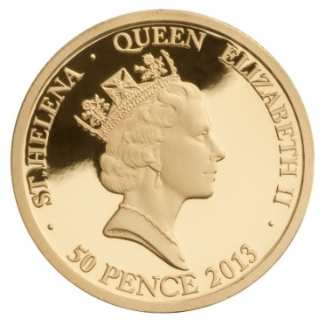
A DESIGN WORTHY OF TWO RULERS
Designed by Former Royal Mint Chief Engraver and Head of Design, Matthew Bonaccorsi, the coin design has been formally agreed and approved by HM Queen Elizabeth II and the Royal Household and is the only official coin issued to celebrate the anniversary between Japan and Britain.
RARE COINS OF THE HIGHEST QUALITY
Struck to the highest ‘proof’ quality available in the minting process, these gold and silver coins are minted by The East India Company, the very Company which, 400 years ago, arrived at the shores of Hirado bearing gifts and official letters from King James I and Vl for the rulers of Japan.
The East India Company Chairman, Mr Sanjiv Mehta commented “The East India Company is pleased to have received the approval by both the Palace and Japan400 to release these very special coins, 400 years since Saris and the Shogun were first introduced back in 1613.”
Mehta adds “Thanks to the actions of few brave men who travelled half way across the world, at a time when travel was anything else but cruise-liner luxury, The Company still fosters a strong trading relationship with Japan today. It’s an honour to be able to join the Japan400 organisation in their celebrations and leaving a lasting memory in the form of silver and gold coins for many years to come.”
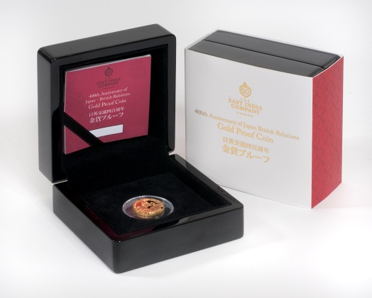
Each coin is carefully mounted in a beautiful presentation case, each with a numbered certificate. With only 400 coins available worldwide, the demand for these coins since the launch has been significant. The coins were placed on general release from 10th September 2013 and the silver coins are now officially sold out. A limited amount of gold coins remain priced at £755.00.
A donation of £100 for each gold coin and £10 for each silver coin is donated to the Japan400 Organisation to ensure that future generations will be able to benefit from the legacy of this special anniversary, through a range of educational and monumental restoration projects.
Japan400 commemorates the start of diplomatic trade, scientific and cultural relations between Britain and Japan in 1613. Through a host of exciting events during 2013, it celebrates the spirit of discovery and mutual regard that has inspired many successful collaborations and a remarkable friendship between two societies on opposite sides of the world. For more details regarding Japan400 events and commemorations, please visit www.japan400.com.
The remaining limited edition gold coins are available to purchase through the following outlets in Japan and the UK:
Japan
Telephone : Free call 0120 – 07- 8222
Internet : www.taiseicoins.com
Email : contact@taiseicoins.com

UK/Rest of the World
Telephone: 0870 803 1186
Internet: www.eicgold.com/japan400 or www.japan400.com
Email: japan400@theeastindiacompany.com

For further information or images of these coins please contact:
EIC CONTACT: Joanna Mould
Email: joanna.mould@theeastindiacompany.com
Tel: +44 (0) 7580 089471
Website: www.eicgold.com/japan400
www.japan400.com

